
FEST Research Group

Final Year Project Weekly Report Log

(To be completed by Student)

S.No | Student Name: | Student ID:
 | Muhammad Umar | 36682
 | Muhammad Bilal Qamar | 35985
 | Adeel Arshsd

Project Title: Rakhwala (child security system)

Dr Mansoor Ebrahim
Supervisor:
Report Week: Date:

Planned Work
Achievements
Integrate ardunio with android app.

50% integration successfully done.
Git Repository :-

https://github.com/MuhammadBilalQamar/Rakhwala-Child-Security-System
FEST Research Group

Proposed work
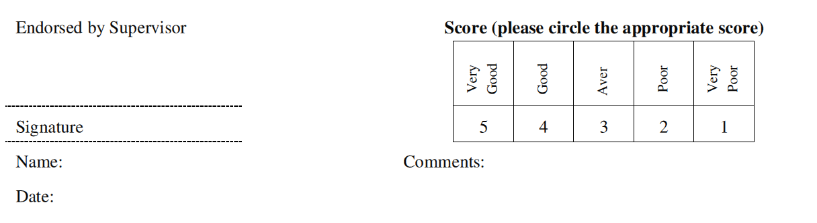
Integrate Ardunio with android app (remaining 50% app)

